STUDY GUIDE FOR ADOBE AFTER EFFECTS
PROVIDE SCREEN SHOTS FOR YOUR WORK
Num | PROJECT | SCREENSHOT
1. | Adobe After Effects 2020-2024 Practice Exam 1  TRAINING MODE  IN SCHOOL ONLY | 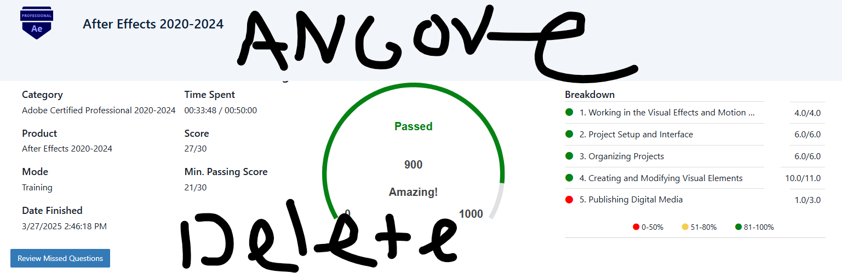
2. | Adobe After Effects 2020-2024 Practice Exam 2  TRAINING MODE  IN SCHOOL ONLY | 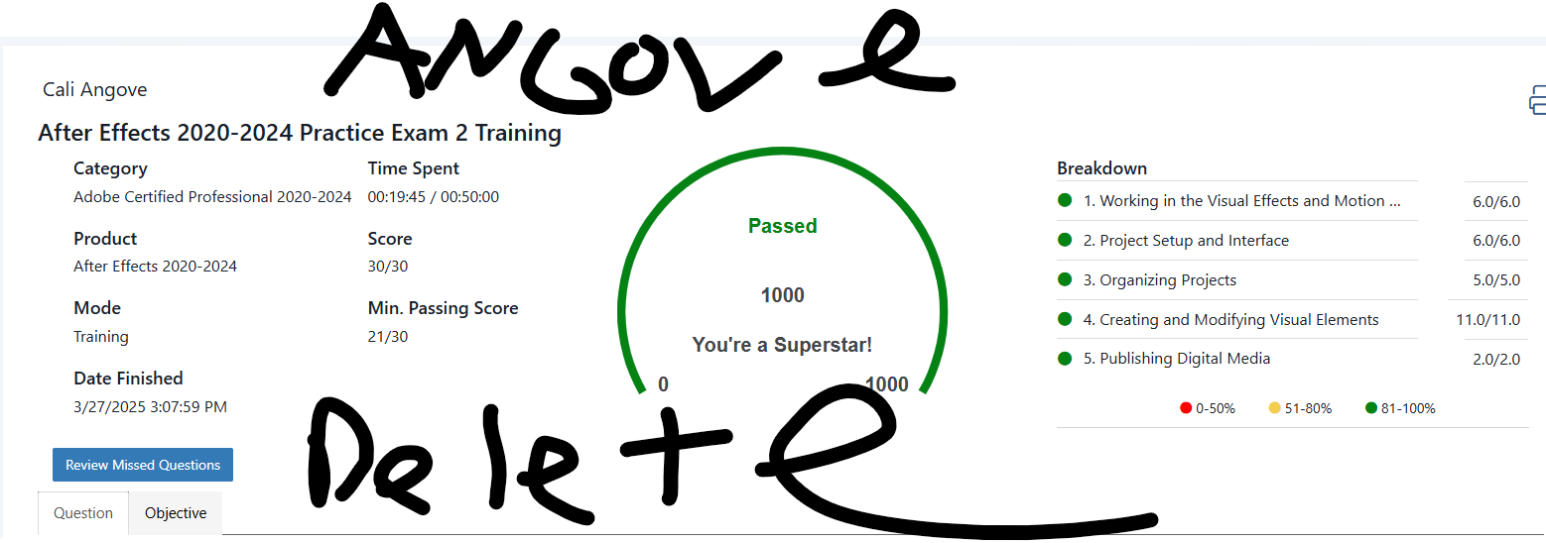
 | OLDER MODE | OLDER MODE
3. | Adobe After Effects CC 2018/2019/2020  Practice Exam 1  TRAINING MODE  IN SCHOOL ONLY | 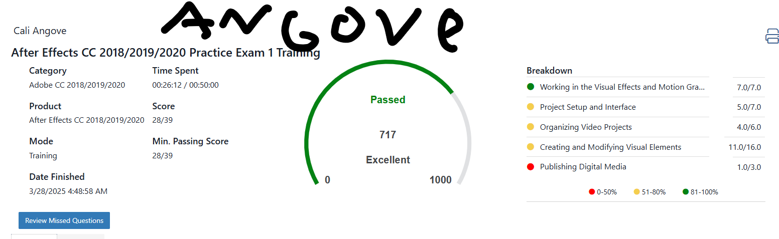
4. | Adobe After Effects CC 2018/2019/2020  Practice Exam 2  TRAINING MODE  IN SCHOOL ONLY | 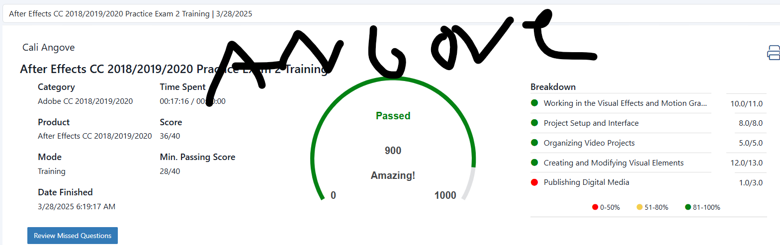
5. | Adobe After Effects CC 2018/2019/2020  Concept Review 1  TRAINING MODE  HOME | 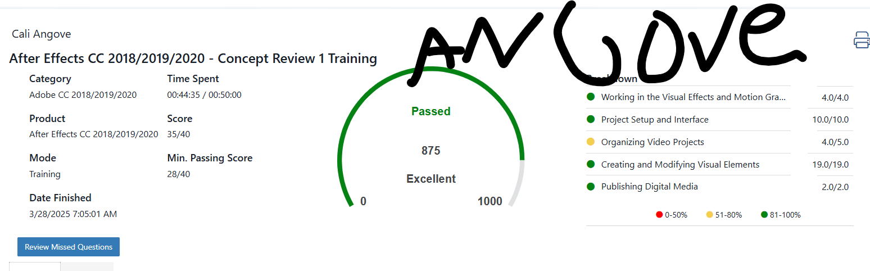
6. | Adobe After Effects CC 2018/2019/2020  Concept Review 2  TRAINING MODE  HOME | 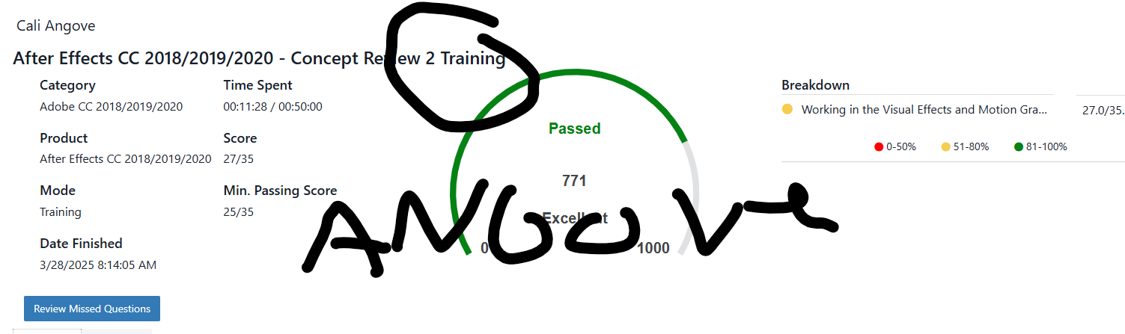
7. | Adobe After Effects CC 2018/2019/2020  Concept Review 3  TRAINING MODE  HOME | 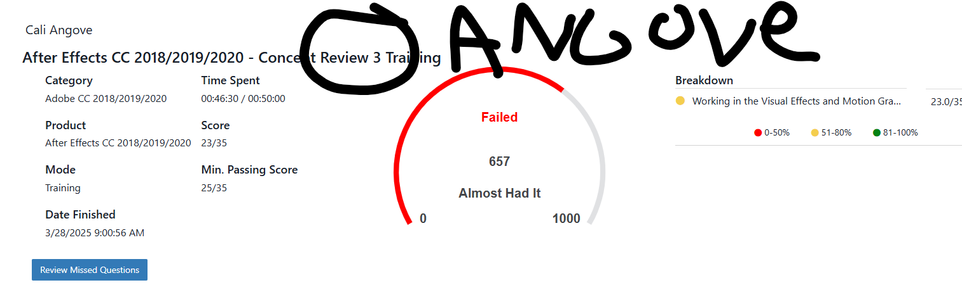
8. | Adobe After Effects 2024-2024 Study Guide  CAN BE DONE AT HOME | 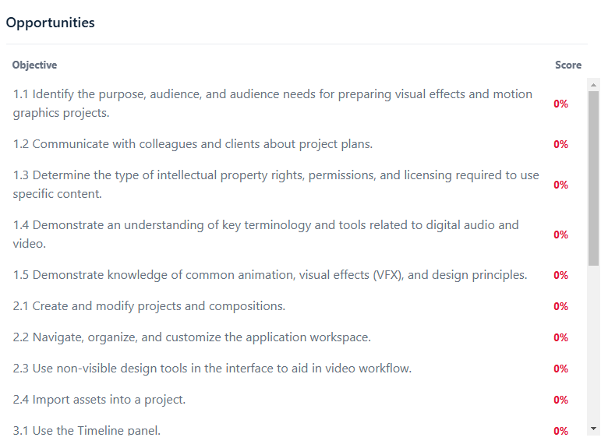
9. | Quizlet / other reviews  If time

